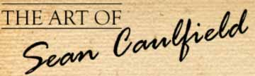 | Latest News: 03-09-2009  Blue Eagle - 8  Mayan Calendar Explained - Day Keeper Course on 12 & 13 September 2009 with Dr. Carl Johan Calleman. For more info & bookings, follow: http://www.281011.com
20 Day Signs of the Mayan Tzolkin Calendar carved by Sean Caulfield

Dimensions = 42cm x 46cm

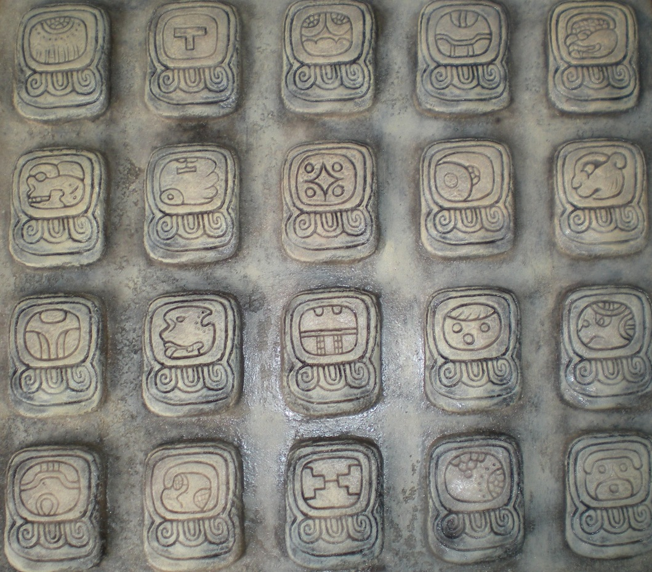

< Click here to see more of Sean Caulfield’s Art >

20 Aspects of the Mayan Tzolkin (Count of days)

The 20 different day signs, or Day Lords, that are part of the Uinal have been given their names in the Yucatec Mayan language. These day energies were followed in ancient time by several native American traditions. The names and symbols of the 20 different Day signs aim to capture some of the spiritual essence of the energy in every day. Since these energies that influenced us human beings are very complex, they can be symbolized not only with a certain range of symbols, but these symbols also may have immensely rich and multi-faceted meanings that are not encapsulated in these few words.

For more information:

www.calleman.com

www.mayanmajix.com
Any queries? Email Cristo Louw, Promotions Manager, info@rockartgallery.com
If you have received this email in error and do not wish to receive further updates from Sean Caulfield or Rock Art Gallery, please email info@rockartgallery.com with “Unsubscribe” in the Subject field.

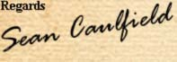  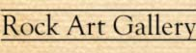  Shop No. 61-67  Blue Shed Craft Market  V&A Waterfront  Cape Town  8002  Phone No: 021 419 7055  Sean's Mobile: 072 859 5309 | 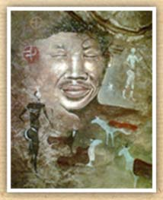
Email: info@rockartgallery.com | Website: www.rockartgallery.com

