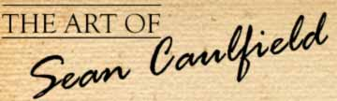 | Latest News: 29-06-2009  Sacred Owl  Today’s Mayan calendar date
Sacred Owl – artist: Sean Caulfield

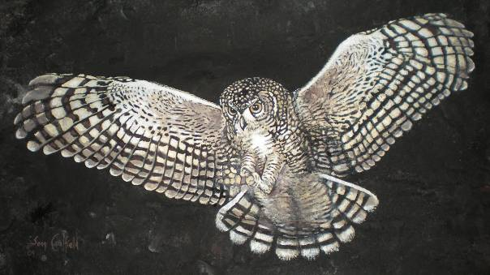
<Click here to view this painting at Rock Art Gallery website>

This painting, on a moulded rock surface, shows off an owl as it stalks from the darkness of the night and about to pounce on its prey. Its prey has no idea it is about to be caught due to the fact that the owl is silent in flight. The owl is a remarkable creature of creation as it has developed extra sensory ability, it has amazing night vision and hearing ability. The feeling one gets when being in the presence of an owl is of ancient wisdom, truth and inner perceptions. In ancient times it was believed that owl held mystical powers. As a symbolic meaning, owl medicine brings magic, wisdom and clarity, and owl cannot be deceived as it works with the truth of any situation.

On the Mayan calendar, people born into the day sign Owl (Cib) - are people that embody the wisdom of the past and often have unusual abilities of a psychic nature. It is not an easy day sign to be born into and they may have a lot of karmic cleansing to deal with. On the surface Owls may be jolly and humorous, but underneath they are very deep and serious. Usually it is referred to as Vulture, which points to a somewhat lazy nature of this Southern sign. They are bent to introspection from which they derive much wisdom, and they often help their fellow human beings with their psychic abilities. Their challenge in life is to find an ethical way of taking it easy.
For more information about the understandings of the Mayan calendar as verified by the elders alive today –
please go to www.mayanmajix.com and www.calleman.com

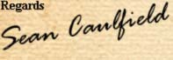  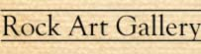  Shop No. 61-67  Blue Shed Craft Market  V&A Waterfront  Cape Town  8002  Phone No: 021 419 7055  Sean's Mobile: 072 859 5309 | 
Email: info@rockartgallery.com | Website: www.rockartgallery.com

